



FAST School of Computing
National University of Computer and Emerging Sciences

Course: Software Engineering

Project Title: Senti Mind — Mental Health Journaling & Clinical NLP Analysis Platform

Members:
Abdullah Mushtaq ............ 23L-0892

Deliverable No: 1

Date of Submission: March 23, 2026

1. Introduction
SentiMind is a full-stack mental health web application that combines personal journaling with a real-time, six-layer clinical NLP analysis pipeline. Users type their thoughts freely; within seconds, the system analyses emotional spectrum, clinical conditions, semantic context, and crisis risk — then delivers a compassionate AI-generated insight alongside evidence-based coping strategies.
The application is architected as a decoupled system: a React/Vite frontend styled with TailwindCSS (Sage colour palette, glassmorphism), a Python FastAPI backend hosting the full NLP pipeline, and an OpenRouter-connected LLM integration for the compassionate response layer. The six pipeline layers are:
- Layer 0 — Preprocessor: Noise cleaning and emoji-to-text translation before any model sees the input.
- Layer 1 — Emotion Detection: DistilRoBERTa (Hugging Face) extracts intensities for 7 core emotions (joy, sadness, anger, fear, disgust, surprise, neutral).
- Layer 2 — Clinical Classifier: LinearSVC (trained via GridSearchCV on Kaggle mental health data) categorises text into 7 states: Anxiety, Depression, Normal, Bipolar, Personality Disorder, Stress, Suicidal.
- Layer 3 — Context Mapper (NER): spaCy Named Entity Recognition extracts subjects and semantic context clues.
- Layer 4 — Risk Logic Engine: Weighted scoring of suicidal confidence, distress keywords, and fearful/sad emotion intensities to output Low / Medium / High / Critical risk tiers.
- Layer 5 — Compassionate AI: LLM (via OpenRouter) injected with the clinical context to generate an empathetic insight and bulleted coping strategies.

Sprint 1 delivered the complete working pipeline, the full React frontend including the EmotionChart and InsightModal components, and cloud deployment on Vercel (frontend) and Render (backend).

2. User Stories
All user stories belong to the single Epic: Core Sentiment & Clinical Analysis Pipeline. Each story follows the standard format; sub-stories define the implementable tasks within each story.

US-01 | Text Input and Submission
- Priority: High
- Estimated Hours: 8
- User Story: As a user, I want to input my thoughts and feelings into a clean interface, so that I can receive a rapid analysis of my mental state.
- Description: Developing a React frontend text area connected to a FastAPI backend with a Layer 0 Preprocessor for noise cleaning and emoji translation.
- Sub-Stories:
  - Sub-Story 1.1: Develop a React frontend with a text area for user input.
  - Sub-Story 1.2: Create a FastAPI backend endpoint (/analysis/) to receive the text payload.
  - Sub-Story 1.3: Implement a Layer 0 Preprocessor to clean noise and translate emojis into text before processing.
- Acceptance Criteria:
  - The text area accepts and submits free-form input successfully.
  - Emojis and noise are translated or removed prior to pipeline processing.

US-02 | Emotional Spectrum Detection
- Priority: High
- Estimated Hours: 10
- User Story: As a user, I want the system to detect my underlying emotions, so that I can visually understand the complex emotional spectrum of my input.
- Description: Integration of Hugging Face DistilRoBERTa (Layer 1) to extract 7 core emotional intensities and visualize them via an interactive EmotionChart component.
- Sub-Stories:
  - Sub-Story 2.1: Integrate Hugging Face DistilRoBERTa (Layer 1) to extract 7 core emotional intensities.
  - Sub-Story 2.2: Build an interactive EmotionChart component in the frontend to visually graph the returned emotion scores.
- Acceptance Criteria:
  - All 7 emotion scores are returned and rendered correctly in the EmotionChart.
  - The EmotionChart updates dynamically with each new analysis.

US-03 | Clinical Categorization
- Priority: High
- Estimated Hours: 12
- User Story: As a user, I want to know if my text reflects specific clinical conditions, so that I gain awareness of my potential mental health baseline.
- Description: Training a Custom ML Classifier (LinearSVC with balanced weights) on Kaggle mental health data to categorize text into 7 clinical states.
- Sub-Stories:
  - Sub-Story 3.1: Train a Custom ML Classifier (LinearSVC) to categorise text into 7 states: Anxiety, Depression, Normal, Bipolar, Personality Disorder, Stress, and Suicidal.
  - Sub-Story 3.2: Develop a cross-validation script (train_model.py) to systematically fine-tune model parameters via GridSearchCV.
- Acceptance Criteria:
  - The classifier returns one of the 7 defined clinical categories for any given input.
  - Model achieves acceptable validation accuracy via GridSearchCV fine-tuning.

US-04 | Crisis Risk Assessment
- Priority: Critical
- Estimated Hours: 14
- User Story: As a user or clinician, I want the application to identify critical distress signals, so that high-risk situations are immediately flagged for safety protocols.
- Description: Using spaCy NER (Context Mapper / Layer 3) to extract subjects and semantic context, combined with a Risk Logic Engine (Layer 4) to compute a weighted risk score.
- Sub-Stories:
  - Sub-Story 4.1: Implement spaCy NER (Context Mapper / Layer 3) to extract subjects and semantic context.
  - Sub-Story 4.2: Build a Risk Logic Engine (Layer 4) to calculate a weighted risk score based on suicidal confidence, distress keywords, and fearful/sad emotion intensities.
  - Sub-Story 4.3: Design a dynamic RiskBadge UI component that visually alerts the user to Low, Medium, High, or Critical risk tiers.
- Acceptance Criteria:
  - The RiskBadge correctly displays one of four tiers: Low, Medium, High, or Critical.
  - Critical risk inputs trigger immediate UI safety alerts.

US-05 | Compassionate AI Insights & Strategy
- Priority: High
- Estimated Hours: 10
- User Story: As a user in distress, I want personalized, empathetic feedback and coping strategies, so that I have constructive, actionable ways to manage my current state.
- Description: Integration of a Large Language Model (Layer 5 via OpenRouter) injected with the calculated clinical context to synthesize compassionate responses, rendered via a custom Markdown parser (InsightModal.jsx).
- Sub-Stories:
  - Sub-Story 5.1: Integrate a Large Language Model (Layer 5 via OpenRouter) injected with the calculated clinical context to synthesize a compassionate response.
  - Sub-Story 5.2: Develop an elegant custom Markdown parser (InsightModal.jsx) to style the AI's core insight and bulleted coping strategies using glassmorphism.
- Acceptance Criteria:
  - The LLM response is contextually relevant to the user's full clinical profile.
  - The InsightModal renders formatted Markdown with glassmorphism styling.

3. Structured Specifications
Below are four structured specifications for US-04 (Crisis Risk Assessment), the most safety-critical user story in the SentiMind pipeline.
Type | Specification
Functional | The Risk Logic Engine must calculate a composite weighted risk score using three inputs: the suicidal confidence output from the ML classifier (Layer 2), the count of distress keywords matched via the spaCy Context Mapper (Layer 3), and the combined intensity of fearful and sad emotion scores from DistilRoBERTa (Layer 1).
Functional | The system must map the computed risk score to one of four discrete tiers — Low, Medium, High, or Critical — and return this tier as part of the final API payload to the frontend RiskBadge component.
UX | The RiskBadge component must employ a distinct, high-contrast colour scheme for each tier (green for Low, yellow for Medium, orange for High, red for Critical) and must be rendered prominently above all other result components to ensure it is seen first by the user.
Performance | The entire 6-layer pipeline must complete computation and return the API response within an acceptable latency threshold. The asynchronous LLM integration (Layer 5) must include a strict 30-second timeout fallback to prevent the UI from freezing, falling back to a static compassionate response if the LLM fails.

4. Scrum Board — Sprint 1
The table below represents the Trello Scrum Board state at the end of Sprint 1, organised into three columns: To Do, In Progress, and Done.
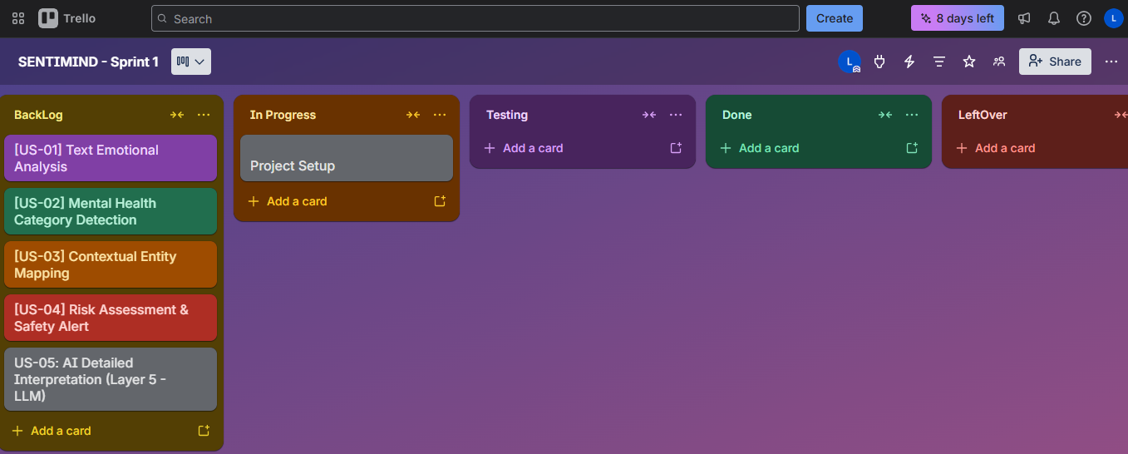
Snapshot 1 — Trello board showing the initial Sprint 1 backlog in the "To Do" column.
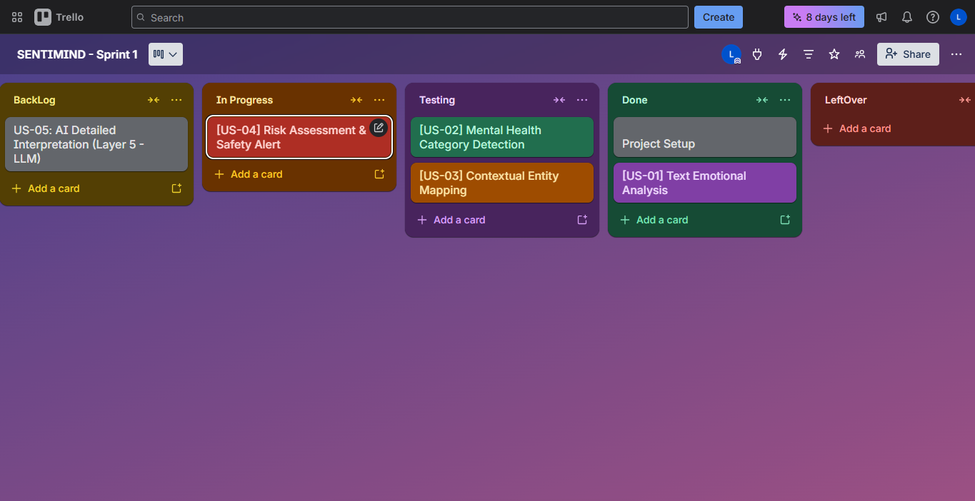
Snapshot 2 — Trello board mid-sprint, with tasks moved to "In Progress" and "Done".
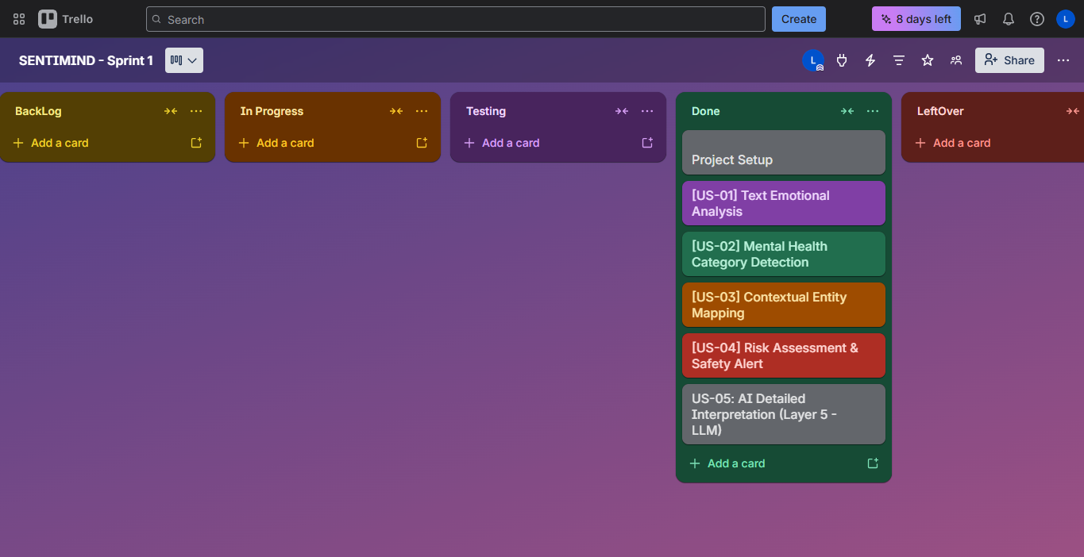
Snapshot 3 — Trello board at end of Sprint 1 showing all completed tasks.

5. Non-Functional Requirements (NFR) Specification
NFRs are expressed in natural language and grouped by quality attribute. Each requirement includes a measurable acceptance criterion.
- Performance & Latency: The 6-layer analysis pipeline must process all NLP tasks and return the final API payload efficiently. Asynchronous integration with external LLMs must include strict timeout fallbacks (30 seconds) to prevent the UI from freezing, falling back to a statically generated compassionate response if the LLM fails.
- Security & Privacy: API access must be rigorously locked down via explicit CORS configurations, securely fetching ALLOWED_ORIGINS from production environment variables. Sensitive API keys (OpenRouter, HuggingFace, JWT Secrets) must be strictly isolated from the codebase via .env management.
- Deployability & Compatibility: The application backend must be strictly compatible with Python 3.11/3.12. The infrastructure must be fully containerised and dynamically stateless to support zero-downtime automated deployment on Platforms as a Service (Vercel for Frontend, Render for Backend).
- Usability & Aesthetics (UI/UX): The frontend must adhere to modern UI/UX principles, utilising a calming "Sage" colour palette and responsive glassmorphism structures via TailwindCSS to minimise user anxiety while interacting with mental health data.

6. Iteration 1 — Implementation Screenshots

Screenshot 1: Main Analysis Interface — Text Input & Submit Button
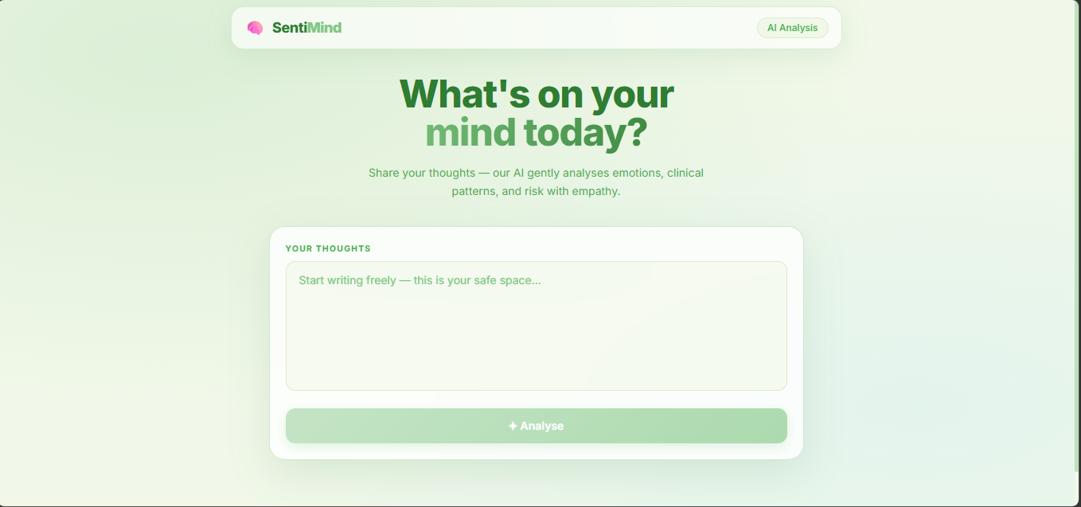
Main SentiMind analysis interface showing the text input area and submit button.

Screenshot 2: EmotionChart — 7-Emotion Radar/Bar Visualisation
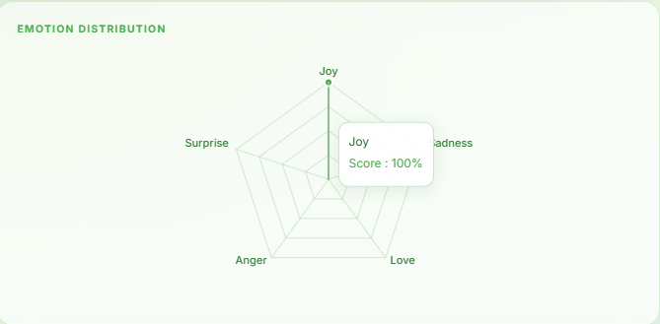
EmotionChart component displaying 7 core emotion intensity scores returned from DistilRoBERTa.

Screenshot 3: Clinical Label Badge with Confidence Score
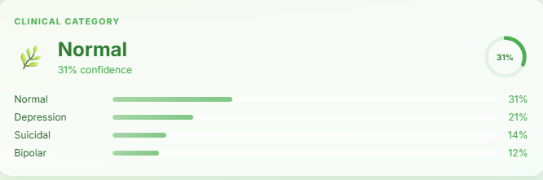
Clinical category label badge returned by the LinearSVC classifier with confidence score.

Screenshot 4: RiskBadge — All Four Tiers (Low / Medium / High / Critical)
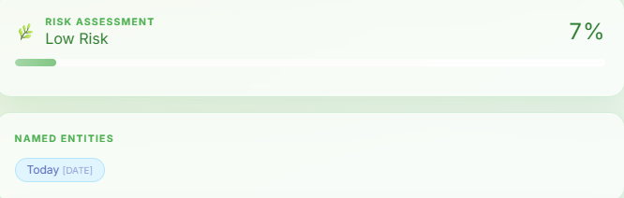
RiskBadge UI component demonstrating all four risk tier states with their colour coding.

Screenshot 5: InsightModal — Compassionate AI Insight with Glassmorphism Styling
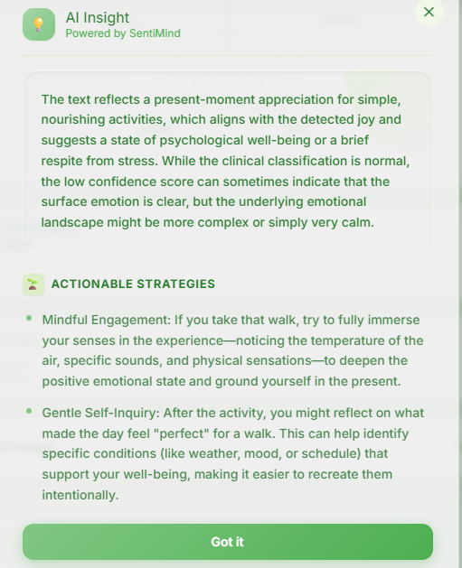
InsightModal displaying the LLM-generated compassionate insight and coping strategies with glassmorphism styling.

7. Work Division
SentiMind is a solo final-year project. All tasks were designed, implemented, tested, and documented by Abdullah Mushtaq (23L-0892). The table below provides the full breakdown by subsystem for assessment transparency.
Subsystem | Owner
Layer 0–4 NLP Pipeline (FastAPI Backend) | Abdullah Mushtaq (23L-0892)
LinearSVC Classifier Training & GridSearchCV | Abdullah Mushtaq (23L-0892)
React Frontend (EmotionChart, RiskBadge) | Abdullah Mushtaq (23L-0892)
InsightModal & LLM Integration (OpenRouter) | Abdullah Mushtaq (23L-0892)
CORS Security & .env Configuration | Abdullah Mushtaq (23L-0892)
Cloud Deployment (Vercel + Render) | Abdullah Mushtaq (23L-0892)
Documentation & Scrum Board | Abdullah Mushtaq (23L-0892)

— End of Deliverable 1 / Sprint 1 —

